Define and Backtest a Simple Strategy
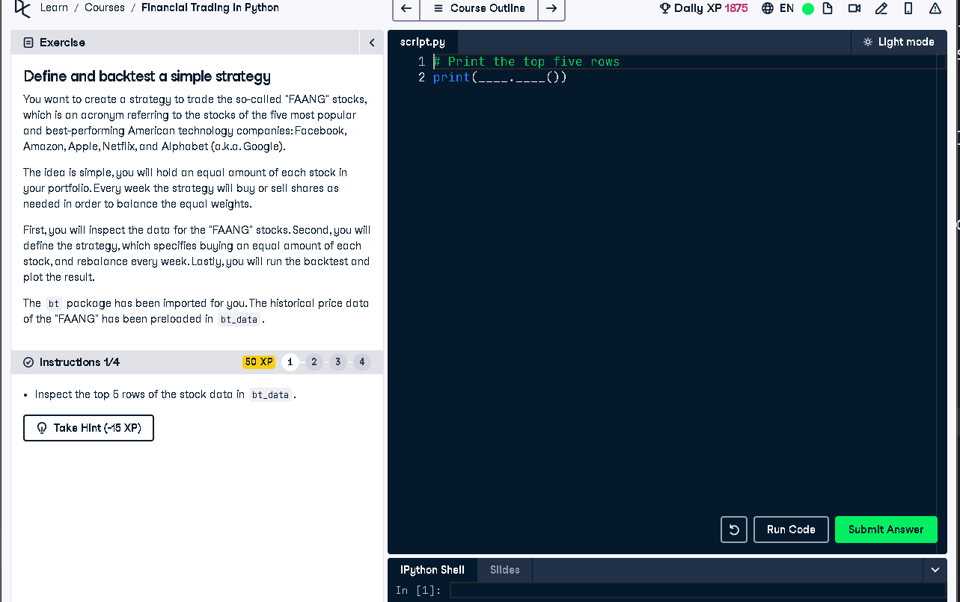

Python Code
# Print the top five rows
print(bt_data.head())

Explanation (50 Words)
To begin backtesting the FAANG strategy, we first inspect the top 5 rows of the historical price data stored in `bt_data`.
This helps ensure the dataset is correctly loaded and formatted before we define the strategy and proceed with rebalancing
and testing portfolio performance.

